1. Searching for high-profile open source android projects from github.
   1. For example,
      1. LeafPic
      2. AmazeFileManager.
2. Put the source code into the our project data repo :
   1. <https://drive.google.com/drive/folders/15X6AKKwtoipcvED6UCcdmhYNPBn4n21U?usp=sharing>
   2. Update the project_list.xlsx

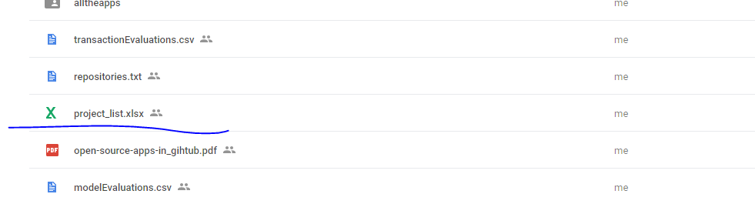

1. Download Eclipse package from here: <https://drive.google.com/drive/folders/1bD77wI0-nT-j5qUkLGuM6S5DgmtG1Jb0?usp=sharing>

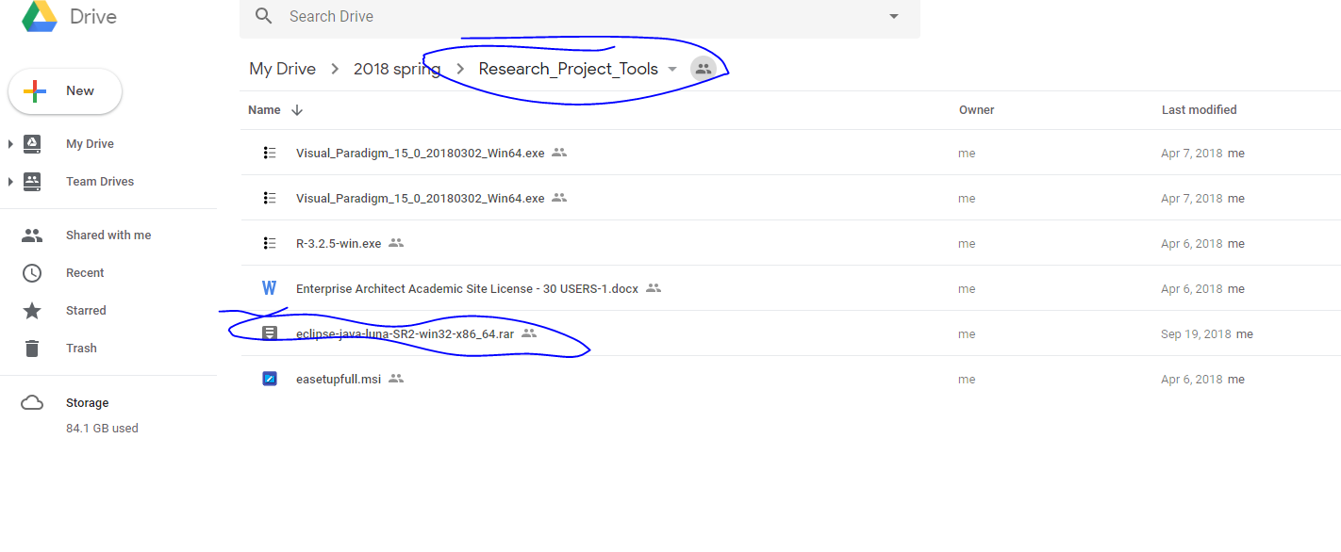

1. Run command the following command to generate the eclipse_kdm.xml file (replacing the paths according your environment)

"C:\Users\Billy\GitHub\eclipse\eclipse-java-luna-SR2-win32-x86_64\eclipse\eclipse" -consoleLog -console -noExit -application testMonitor3.id5 "C:\Users\Billy\GitHub\rufusmms-20180916T222343Z-001\rufusmms" "C:\Users\Billy\GitHub\rufusmms-20180916T222343Z-001\rufusmms\kdm.xml" -vmargs -Xmx10240M

1. Copy response-patterns.txt to the root folder of the project.

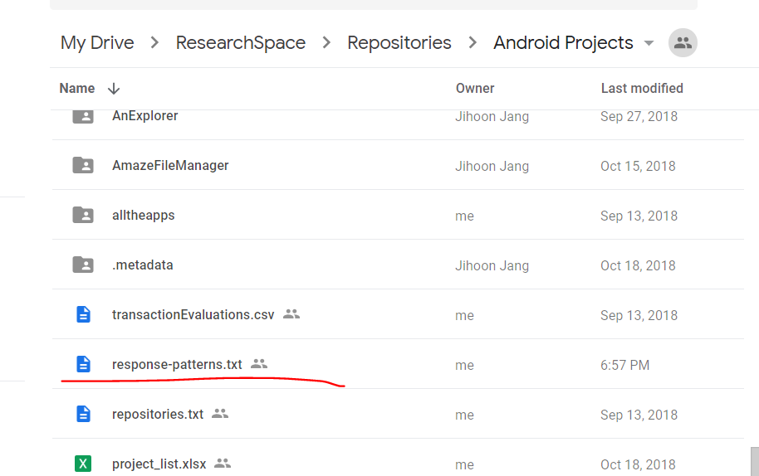

1. Run command to generate the analysis results using the generated eclipse_dkm.xml file.

node ./UMLxAnalyticToolKit.js <input file> <output dir> <project name>

For example,

node ./UMLxAnalyticToolKit.js "./data/StandAloneToolKit/f14a_e_lock_box.xml" "./data/StandAloneToolKit/output" "f14a_e_lock_box" -vmargs -Xmx10240M

potential error:

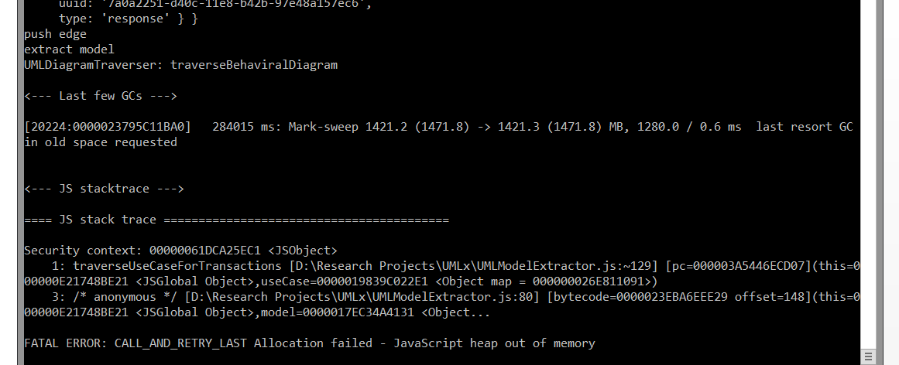

1. For the open source Android projects, run this command:

"C:/Program Files/R/R-3.2.5/bin/Rscript" ./UMLx/data/OpenSource/active_contributors_every_30.R "https://api.github.com/repos/apache/carbondata" "./temp/git_effort_request_results.txt"

The URL is the exactly the same as the URL of the open source project at Github, but an api URL for the project. It follow similar patterns. Just try to change the example into specific URL.

1. Generate report about lines of source code by running the following commands:
2. node --max_old_space_size=10240 ".\utils\OpenSourceProjectAnalysis.js" --select-files "C:\\Users\\flyqk\\Documents\\Research Projects\\UMLx\\data\\Rufuslabs\\repo1.json"

Ps. Adjust the paths in repo1.json according to your environment and you can add multiple projects to do a batch run.

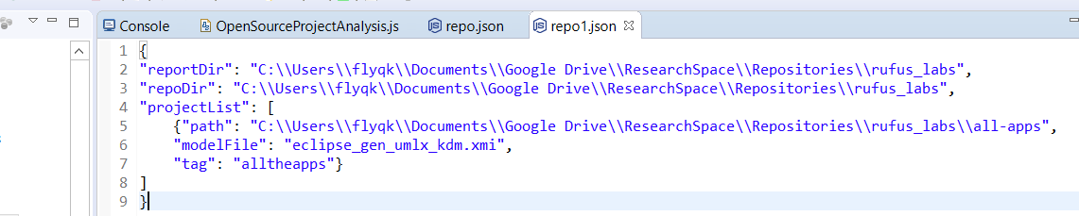

This will pop up a window to show the source code directory that you specified. And then you select the source file folders that contain the code. After that, hit the save button to save your selection.

1. node --max_old_space_size=10240 ".\utils\OpenSourceProjectAnalysis.js" --analyse-sloc "C:\\Users\\flyqk\\Documents\\Research Projects\\UMLx\\data\\Rufuslabs\\repo1.json"

and then:

node --max_old_space_size=10240 ".\utils\OpenSourceProjectAnalysis.js" --generate-sloc-report "C:\\Users\\flyqk\\Documents\\Research Projects\\UMLx\\data\\Rufuslabs\\repo.json"

This will generate a report for the analysis results for the code in terms of source lines of code.

1. node --max_old_space_size=10240 ".\utils\OpenSourceProjectAnalysis.js" --calculate-cocomo-estimation-result "C:\\Users\\flyqk\\Documents\\Research Projects\\UMLx\\data\\Rufuslabs\\repo.json"

This command will generate the effort estimated by COCOMO.